ASSIGNMENT 5 PART 1
CODE :
//Merwin Pinto
//202100102
//Div D
//Assignment on Linear search ( Asst 5 )
//Linear search
//Merwin Pinto
//202100102
//ASST 5
#include <stdio.h>
int linear_search(int array[], int num, int a)
{
for (int i = 0; i < num; i++)
if (array[i] == a)
return i;
return -1;

}

int main()
{
int a ,num ,result ,b,c ;
int array[] = {10, 7, 4, 3, 2, 1 ,5};
printf("Enter the number you wish to find from array array[] = {10, 7, 4, 3, 2, 1 ,5} \n");
scanf("%d",&a);
b = sizeof(array);
c = sizeof(array[0]);
num = b / c;
result = linear_search(array, num, a);

if (result == -1)
printf("Not found");
else
printf("Element is found at index %d", result);
}

OUTPUT :
Linear Search :
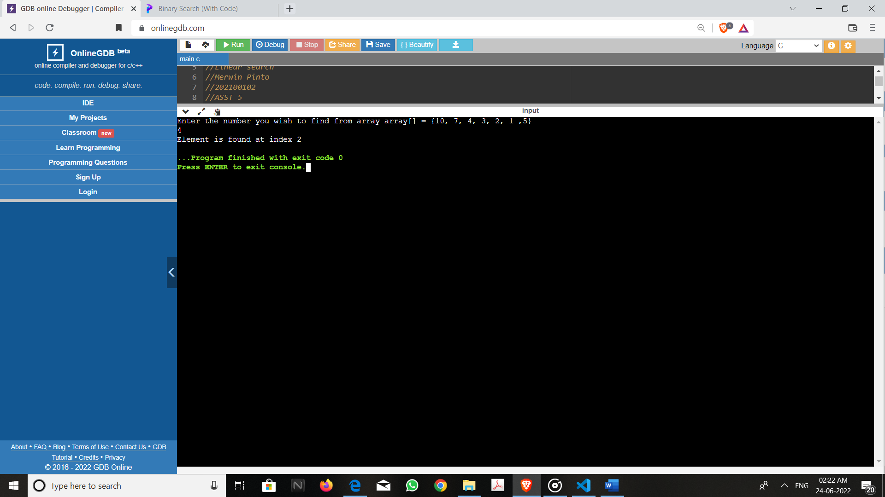
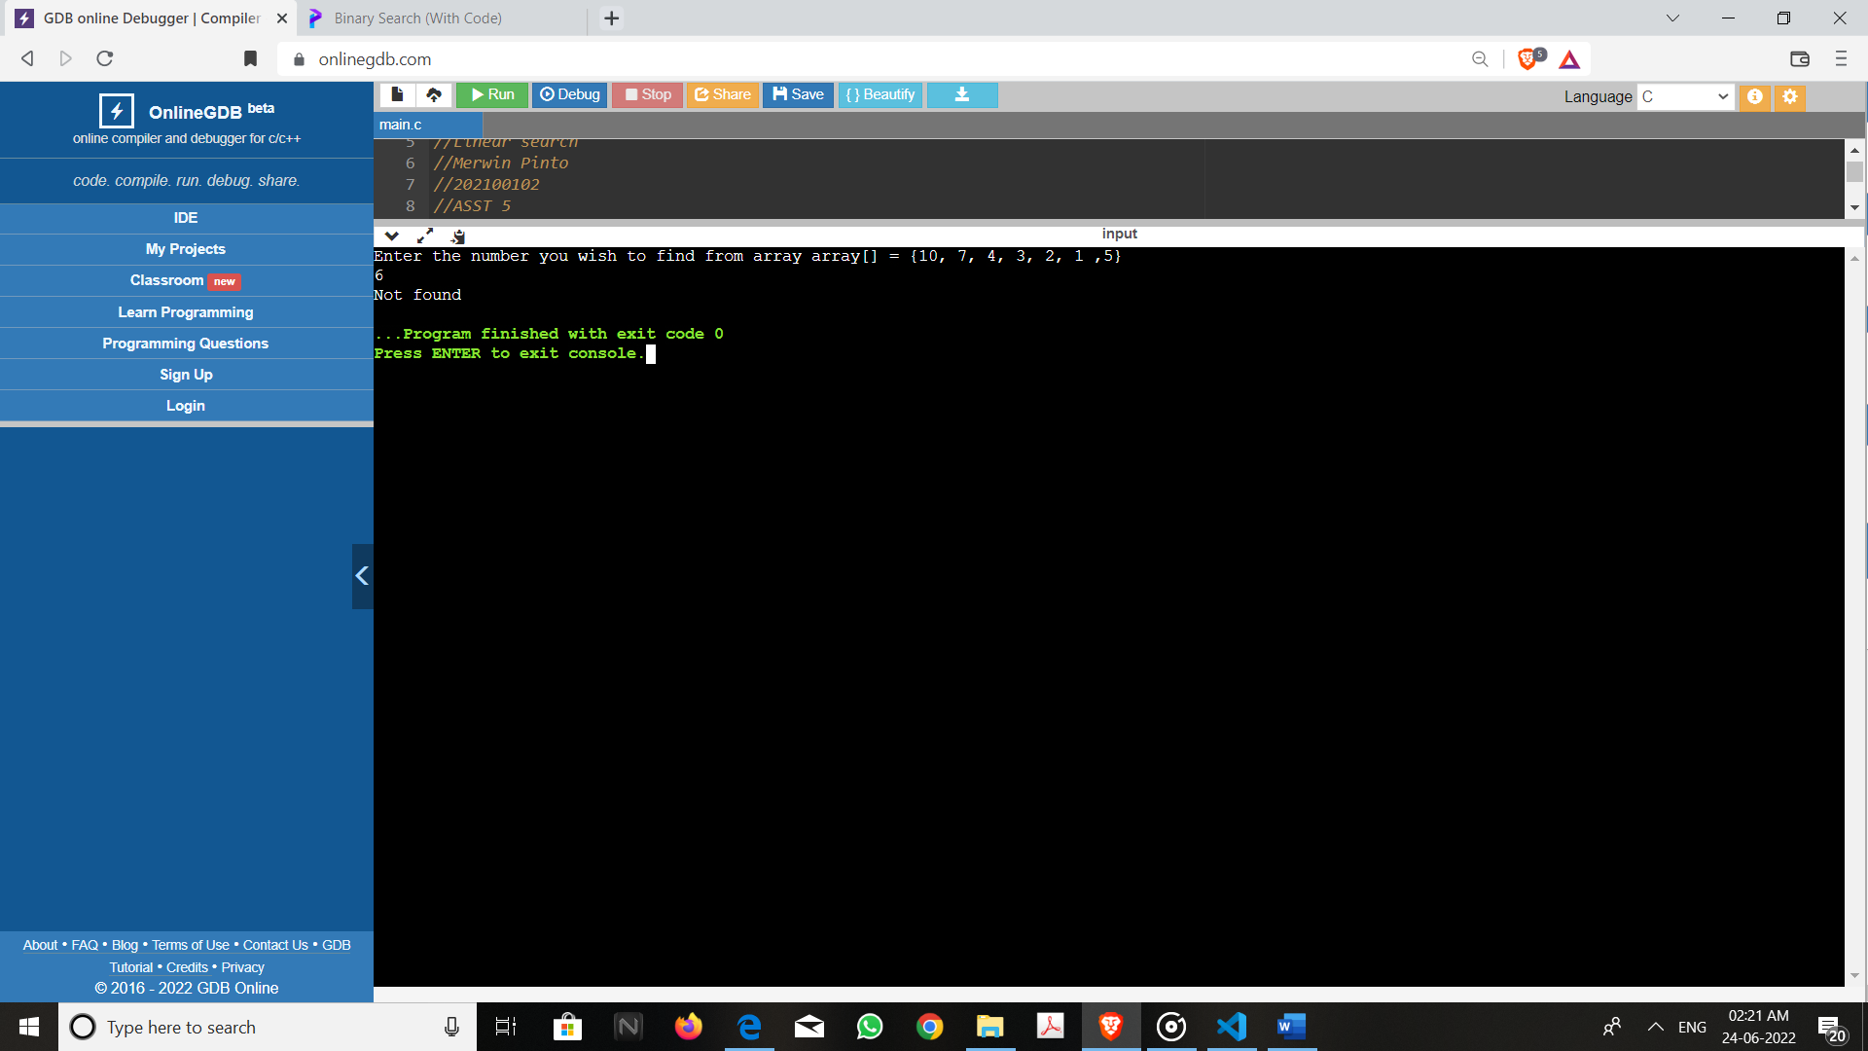

ASSIGNMENT 5 PART 2
CODE :
//Merwin Pinto
//202100102
//Div D
//Assignment binary search ( Asst 5 )
//Binary Search
CODE :
// Linear search
//Merwin Pinto
//202100102
//ASST 5
// #include <stdio.h>

// int linear_search(int array[], int num, int a)
// {
// for (int i = 0; i < num; i++)
// if (array[i] == a)
// return i;
// return -1;

// }

// int main()
// {
// int a ,num ,result ,b,c ;
// int array[] = {10, 7, 4, 3, 2, 1 ,5};
// printf("Enter the number you wish to find from array array[] = {10, 7, 4, 3, 2, 1 ,5} \n");
// scanf("%d",&a);
// b = sizeof(array);
// c = sizeof(array[0]);
// num = b / c;
// result = linear_search(array, num, a);
// (result == -1) ?
// printf("Element not found") : printf("Element found at index: %d", result);

// }

// Binary Search

#include <stdio.h>
int binarySearch(int array[], int val, int low, int high)
{
while (low <= high)
{
int mid = low + (high - low) / 2;

if (array[mid] == val) // mid is Equivalent
return mid;

if (array[mid] < val) //mid is smaller
low = mid + 1;

else //mid is larger
high = mid - 1;
}
return -1;
}

int main(void)
{
int val ,num ,result ,b,c ;
int array[] = {3, 4, 5, 6, 7, 8, 9};
printf("Enter the number you wish to find from array array[] = {3, 4, 5, 6, 7, 8, 9} \n");
scanf("%d",&val);
b = sizeof(array);
c = sizeof(array[0]);
num = b / c;
result = binarySearch(array, val, 0, num - 1);

if (result == -1)
printf("Not found");
else
printf("Element is found at index %d", result);
return 0;
}

OUTPUT :
